COLONIAL NEWS
Health Committee Newsletter March 2023

Welcome to the Albert Gallatin School District Health Committee’s monthly newsletter. Each month this publication will provide our district with health and fitness information. Our goal is for our students, families, and staff to use this information to make healthy decisions and to live a healthy active lifestyle.

HOW MUCH PHYSICAL ACTIVITY DO YOU NEED?

ADULTS
At least 150 minutes
of moderate-intensity
aerobic activity every
week. Try walking 30 minutes a day, 5 days a week. Muscle-
strengthening activities
at least 2 days a week

CHILDREN
(6-17 years)
60 minutes (1 hour)
or more of physical
activity each day

PRESCHOOL-
AGED CHILDREN
(3-5 years)
should be
physically active
throughout the day
with plenty of opportunities
for active play.
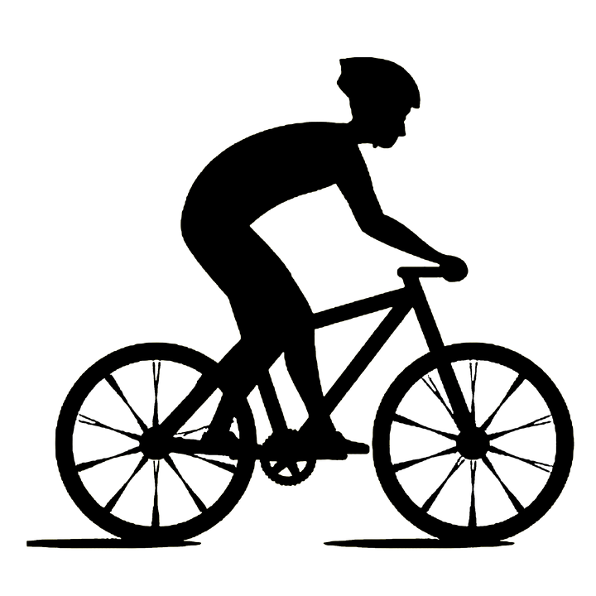
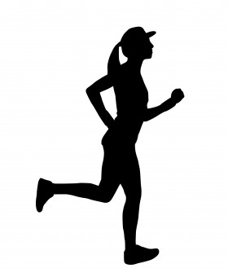

Strategies for a Healthy Spring
Help prevent chronic diseases like type 2 diabetes, heart disease, and cancer with these healthy habits for spring.

1. Move more, sit less…physical activity is beneficial to everyone —no matter your age, gender, race or ethnicity, health condition, shape or size.

2. Eat healthy foods…by choosing fruits, vegetables, whole grains, lean meats, and low-fat dairy products. TIP – place fruits and vegetables on half your plate and whole grains on the other half.

3. Drink plenty of water…Substitute water for sugary drinks to reduce calories and stay hydrated.

4. Get enough sleep…Adults need at least 7 hours of sleep per night, children aged 6 to 12 need 9–12 hours of sleep per night and teens 13 to18 need 8–10 hours of sleep per night.

5. Be sun safe…by wearing long-sleeved shirts and long pants, a wide-brimmed hat, and sunglasses and use broad-spectrum sunscreen with at least SPF 15. Wearing sunglasses that block both UVA and UVB rays will provide the best protection.
(copied or referenced from Source: CDC’s National Center for Chronic Disease Prevention and Health Promotion)

Prepared by Lisa Sumey, Central Office Secretary
Recipe of the Month

Irish Flag Fruit and

Yogurt Parfait

Ingredients
- Clear Glass or Cup
- Green Grapes
- Vanilla or plain yogurt- Regular style or Greek
- Mandarin Oranges

Directions
  - Place the green grapes in the bottom of the cup or glass.
  - Add the yogurt.
  - Drain the mandarin oranges then add them to the top of the yogurt.

Ideas For Parents/Guardians

Physical Activity Before and After School

How Can You Help?

Encouraging students to be physically active before and after school helps them identify activities they enjoy and might engage in long term. Physical activity before and after school also will help them achieve some of the 60 minutes of physical activity they need each day. Physical activity before and after school could include walking or biking to and from school, physical activity clubs, intramural programs (sports organized by the school or community in which any child can participate), interscholastic sports (competitive sports between schools), and physical activity in before-school and after-school extended day programs. These activities can improve students’ health and their grades and test scores.
(copied from Source: cdc.gov/healthyschools/parentsforhealthyschools/resources.htm)

For additional resources relating to school nutrition, physical education and physical activity go to http://www.cdc.gov/healthyschools/P4HS.htm

